First Order Multiplierless IIR

An important component of this method is the realization of the HPF/LPF. These methods can be implemented without explicit multipliers, are amenable to high-speed operation, and can provide the very deep and narrow notches desired for the overall function. The filters are IIR and very simple implementations result for 1st and 2nd order structures. Both filters are based on transformations of analog filters using the “Mapping of Differentials” method [1].

Figure 1 illustrates the first-order structure.

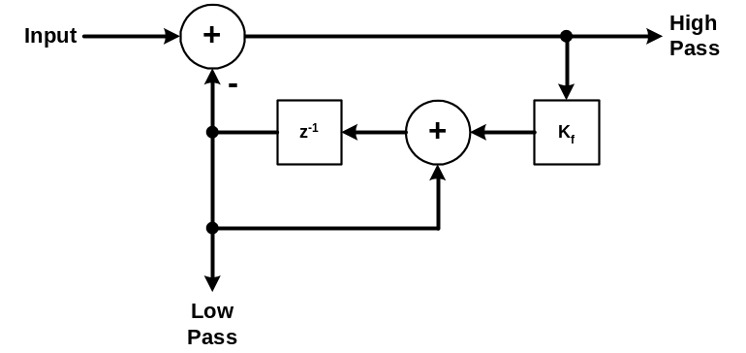

Figure 1. First-Order High/Low Pass Filter.

This structure is based on the analog filter shown in Figure 2. The low-pass output is a estimate of the input signal near dc that is subtracted from the input to yield the high-pass output.

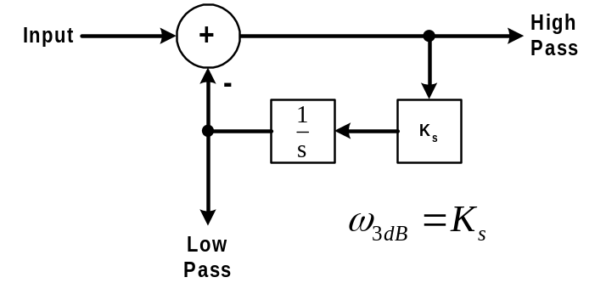

Figure 2. First-Order Analog Prototype.

The transfer functions to the low-pass, L(s), and high-pass output, H(s), are given by

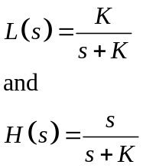

From the transfer function it is seen that the lowpass output is a unity gain estimate of the input signal near dc. This is subtracted from the input to yield the highpass output. From control theory, the existence of an integrator in the loop indicates there will be zero steady-state error at the highpass output of the input summer. This is evidenced by the s in the numerator of the highpass transfer function indicating a zero at dc. The bandwidth is K radians per second. The digital filter is obtained by substituting a digital integrator for the analog integrator. The corresponding digital transfer functions are given by

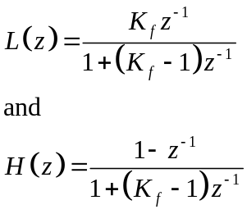

The transformation results in a zero at z = 1, the dual of dc in the z domain. The analog to digital transformation indicates that K and K_{f} are related by

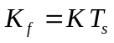

With this, the bandwidth of the filter is approximately given by

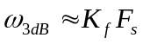

where F_{s} is the sample frequency.

Second Order Butterworth Multiplierless IIR

A second-order filter extending this basic topology is shown in Figure 3.

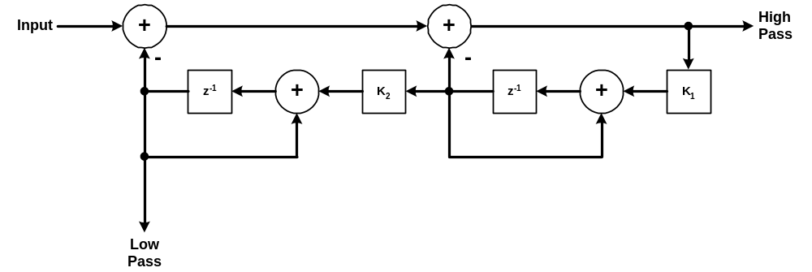
Figure 3. Second-Order Digital High/Lowpass Filter.

The analog prototype for this filter is illustrated in Figure 4.

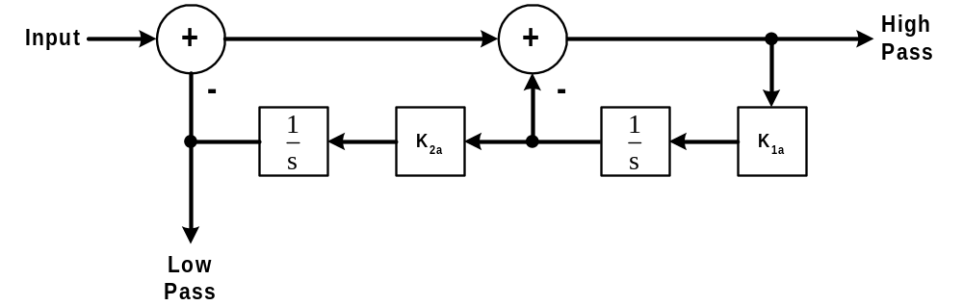

Figure 4. Analog Second-Order Prototype.

The transfer functions for the analog prototype filter are given by

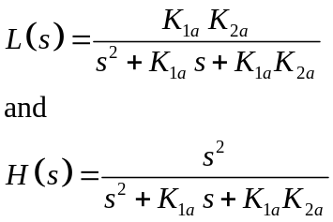

As desired, there is a double zero at dc in the highpass response. The Butterworth response provides a maximally flat response. The polynomial form for the Butterworth denominator is

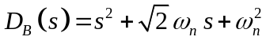

Fitting this response to the above transfer functions yields

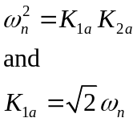

Squaring the second equation and substituting for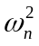 yields

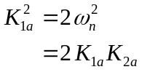

Simplifying this yields

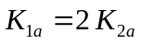

This factor of 2 ratio between the two factors is important to the simple realization of this filter.

Substituting this result for yields

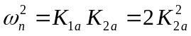

or

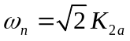

The analog-to-digital mapping provides the following conversions for the gain factor.

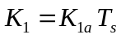

and

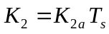

Let

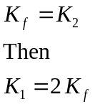

With these assignments, the approximate bandwidth of the digital filter is given by

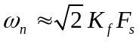

As was the case for the first-order filter, K_{f} controls the bandwidth. If K_{f} is chosen to be a power of 2, both scale factors can be implemented with simple shifts providing low complexity, high-speed implementations.

The transfer function for the digital filters is given by

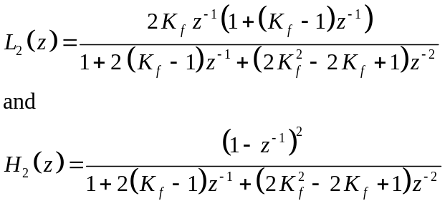

As desired, the highpass response has a double zero at z = 1 corresponding to the double zeros at dc in the analog filter.

Modification for Delay Sensitive Lowpass Filter Applications

The material above was lifted from a paper where the primary application employed the highpass filter output and delay was of no importance. When lowpass filters are used in servo loop applications, it is imperative to minimize delay and the resulting phase lag that it produces.

A slight modification to the above figures and transfer functions can reduce the delay for the lowpass outputs. In both digital figures, a unit delay can be removed by taking the lowpass output from the indicated position and moving it back to the right side of the delay element, i.e., to the output of the summer feeding the indicated lowpass output register. This is the same value that appears at the output; just one sample earlier. In the transfer functions, this results in a z⁻¹ term in the numerator disappearing. The transfer functions then become
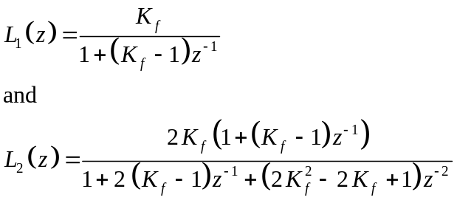

The same amplitude response but less phase lag because the output occurs one clock sooner. In software this is a pretty obvious thing to do but in hardware it’s not so apparent.

